Prize levels – All individual prizes are cumulative!

I ran ______

laps!!

My goal is the ______ prize!

$0-49 $50-74 $75-99 $100-149 Run4Fund$ T-Shirt Loop Pencil Kona Ice Fuzzy Dice
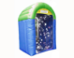
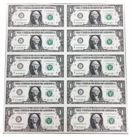
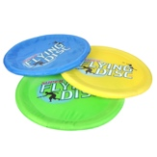

$150-199 $200-299 $300-499 $500+
Human Hamster Ball Flying Disk 10 Seconds in Money Machine Money Poster
Name: |  | Teacher: |  | Grade:

Donor List

FUN RUN INFORMATION:
Each Lap = 1/16th of a mile (16 laps = 1 mile) Total Run/Walk Time = 30 minutes Average Laps = 25 laps
Sponsor Name | Pledge Per Lap | Flat Donation | Online Pledge | Total Paid
GRAND TOTAL |  |  |  | $
Return cash/check donations in pledge envelope (sent home after the run) OR go online to place a secure donation at www.run4fundscolorado.com/grantranch by Monday, October 09, 2017 to receive prizes and events on Monday, October 16, 2017.
Checks should be made payable to Grant Ranch School PTO
Please return one envelope per child -- do NOT combine pledges between siblings.
Prize pictures are representation only, actual prizes may/will vary. QUESTIONS? Contact: Ed@Run4Fundscolorado.com

